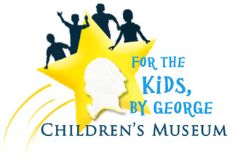

Building Steam! 2015 Annual Fundraiser
to benefit
For The Kids, By George
Children’s Museum
Saturday, October 24th 2015

Corporate Sponsorship Opportunities
Presenting Sponsor - $1,000
- 10 Tickets to the Event
- Company Name/Logo displayed at the Museum for one year
- Company Name/Logo displayed at event and in advertising promoting the event
- Company Name/Logo displayed on website
- Company Name mentioned in Museum monthly newsletters

Engineer Level - $500
- 6 Tickets to the Event
- Company Name/Logo displayed at event and in advertising promoting the event
- Company Name/Logo displayed on website
- Company Name mentioned in Museum monthly newsletters

Conductor Level - $250
- 4 Tickets to the Event
- Company Name/Logo displayed at event and in advertising promoting the event
- Company Name/Logo displayed on website

Station Agent Level - $100
- 2 Tickets to the Event
- Company Name/Logo displayed at event and in advertising promoting the event

Yes! I/We would like to sponsor the Building Steam! 2015 event on October 24th, 2015
__ Presenting Sponsor at $1,000
__ Engineer Sponsorship at $500
__Conductor Sponsorship at $250
__Station Agent Sponsorship at $100

Company Name
________________________________________________
Contact Name
________________________________________________
Address ________________________________________________
City ____________________ State _________
Zip_______________________
Phone ________________________________________________
Email ________________________________________________
__Check is enclosed made payable to For The Kids, By George Children’s Museum

Please mail this completed form along with your payment to:
For The Kids, By George Children’s Museum
229 E Martin St, Ste 2
Martinsburg, WV 25401
(304) 264-9977
director@forthekidsbygeorge.org

The Mission of the For The Kids, By George Children’s Museum is to provide an interactive and engaging environment that immerses children and their families in the history and culture of the Eastern Panhandle of West Virginia and its importance to the founding of our nation.
For The Kids, By George
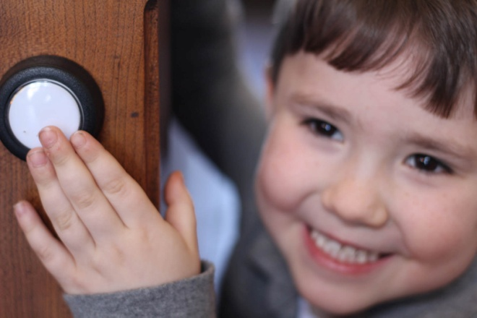

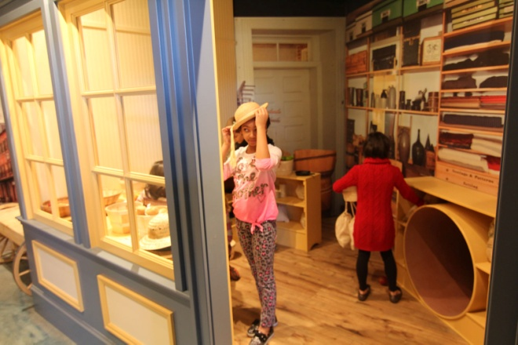
Hours of Operation:
Wednesdays, 10am-4pm
Saturdays, 10am – 5pm
*Open by reservation for Field Trips, Group Tours and Birthday Parties

$6/person for those 2 years old and older

Museum Memberships Available
Family - $75
Grandparent - $50

www.forthekidsbygeorge.org

www.facebook.com/ForTheKidsByGeorgeMuseum

www.twitter.com/4TheKidsMuseum

Three unique, fun and educational Exhibit
Paths to explore!

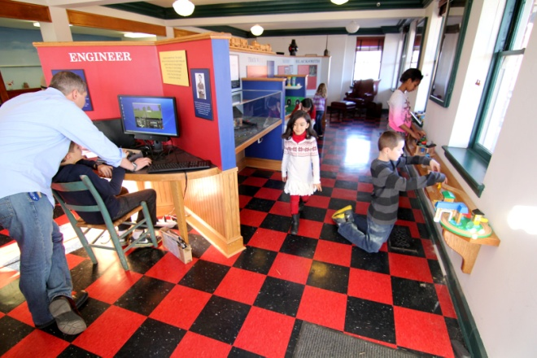

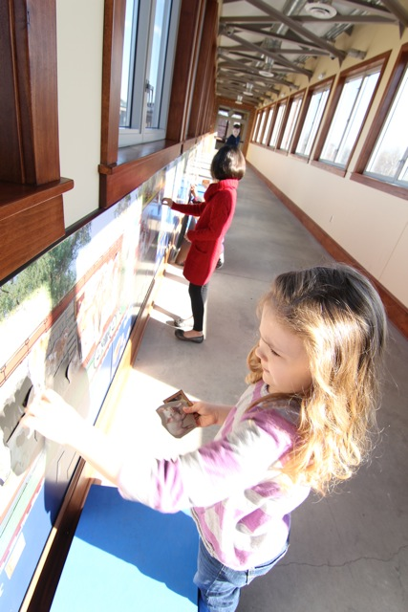

We invite you to join us as a Sponsor for our 2nd Annual “Building Steam!” Fundraiser and to join us at the event to benefit the work of the For The Kids, By George Children’s Museum!

