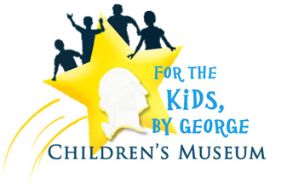
Education Curriculum | West Virginia

The For The Kids, By George Children’s Museum features a Railway Heritage exhibit that explores life on the railroad, Tunnels Through Time where visitors can experience how life changed from one historic era to the next, a trip high above the train tracks to discover how train cars move people, animals and products, a 3-D virtual Bike Tour down the Washington Heritage Trail and a chance to learn more about young George Washington and the time he spent here before the Eastern Panhandle became our own West Virginia.

To make group reservations, call the Museum at 304.264.9977 or email director@forthekidsbygeorge.org.

- Information System

- Museum Starting Point: Waterways of the Eastern Panhandle
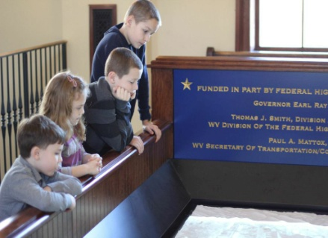
K-5

Students follow George Washington as he paddles down one of the Eastern Panhandle’s many waterways, which parallel the modern day Washington Heritage Trail.

Next Generation Standards:
SS.K.WV.5, SS.1.WV.4, SS.2.WV.2, SS.3.G.1, SS.4.WV.1, SS.5.WV.5

- Eastern Panhandle Then and Now

K-5

Students watch a video about how over time the Eastern Panhandle has changed from the time young George Washington explored and visited the area to the present day. Students will also be able to view a Washington Heritage Trail map and in order to make connections between eras.

Next Generation Standards:
SS.K.H.CL1.4, S.1.H.CL1.1, SS.2.H.C1.1, SS.3.H.CL1.5, SS.4.WV.1, SS.5.WV.5
- The Green Journey – Railroad Heritage

- Working the Railroad
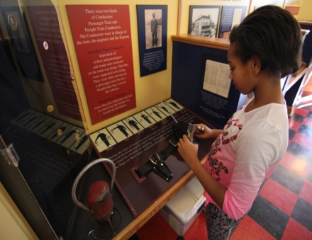
K-5

Students will follow the green trail to numerous railroad exhibits. These exhibits provide hands-on activities highlighting various jobs related to the railroad industry. Activities include educational simulations and stations related to being an engineer, conductor, porter, and telegraph operator.

Next Generation Standards:
SS.K.WV.5, SS.1.WV.2, SS.2.WV.5, SS.3.H.CL1.5, SS.4.WV.2, SS.5.H.CL3.1

- Old Ticket Counter / Lego Replication of Historic Downtown Martinsburg

K-5

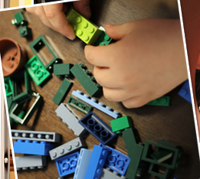
Students pretend to be working in an old-fashion train station dispensing tickets. Additionally, a model of the historic city Martinsburg built from Lego bricks is on display to allow students to identify buildings located in their modern world. Students can also construct their own historic buildings in the Lego building area.

Next Generation Standards:
SS.K.H.CL1.4, SS.K.E.3, SS.1.H.CL1.3, SS.2.WV.5, SS.4.WV.2

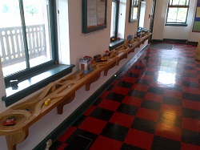
- Train Track Wall

K-5

This hands-on exhibit allows younger students to build their own railway system and learn about the various types of train engines.

Next Generation Standards:
SS.K.E.1, SS.1.WV.5, SS.2.WV.5

- The Great Strike of 1877

K-8
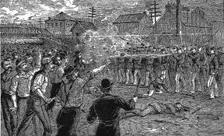
This exhibit focuses on one of the largest labor conflicts in United States’ History. Students will learn about the causes and ramifications of the labor strike on both the city of Martinsburg and the United States. Students will also learn about the geography of the Baltimore and Ohio Railway and how the strike affected other locations along the line.

Next Generation Standards: SS.K.WV.5, SS.1.WV.5, SS.2.WV.4, SS.3.E.4, SS.4.H.Cl4.1, SS.5.WV.5, SS.6-8.L.7, SS.8.H.CL4.1

- The Yellow Journey – Traveling Through Time

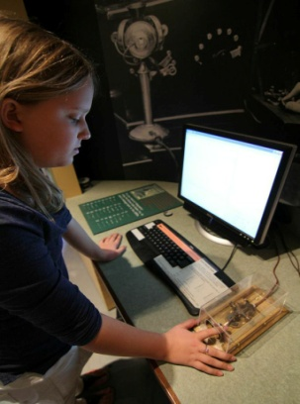
- Character Corridor / Character Passports

K-8

Students will learn about local historic figures throughout the museum tour. Students will receive a passport upon museum entrance connecting them to a specific historic figure. They will follow museum exhibits and use critical thinking skills to answer specific questions related to their historic figure and locate the individual on the museum biography wall.

Next Generation Standards: SS.K.WV.1, SS.1.H.CL1.3, SS.2.H.C1.3, SS.2.WV.4, SS.3.G.10, SS.4.WV.3, SS.5.WV.1, SS.6-8.L.7, SS.6-8.L.8

- Tunnels Through Time
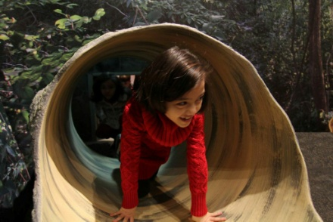
K-5

Students will explore local history from the 1600s, 1700s, and 1800s through the perspective of a Native American settlement, a Colonial Home, and an Industrial Age Shopkeeper. Students can participate in the exhibit using the tools, games, and products from each time period.

Next Generation Standards: SS.K.WV.5, SS.K.E.2, SS.1.WV.5, SS.2.WV.5, SS.3.H.CL1.3, SS.4.WV.2, SS.5.WV.5

- Virtual 3-D Bike Ride Along The Washington Heritage Trail

K-8
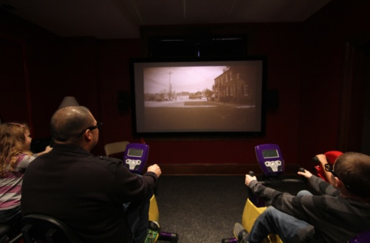
Students ride exercise bikes and view a 3-D video of the Berkeley, Jefferson, and Morgan County portions of The Washington Heritage Trail. The students will learn about the geographic make-up and history of this portion of The Washington Heritage Trail.

Next Generation Standards: SS.K.H.CL1.4, SS.1.G.1, SS.2.G.4, SS.3.G.7, SS.4.G.2, SS.5.G.8, SS.6.G.1, SS.7.G.3, SS.8.G.6

- The Red Journey – Pedestrian Bridge Across the Tracks

- Magnet Wall

K-5

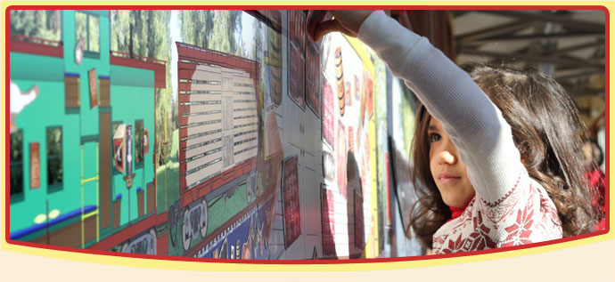
Students manipulate magnets on a wall to demonstrate the uses of two different trains: a cargo train and passenger train. Students will identify the appropriate cargo and passengers for both engines. Students can use their imagination to act out different scenarios for both trains.

Next Generation Standards: SS.K.WV.5, SS.1.WV.2, SS.2.WV.5, SS.3.H.CL1.5, SS.4.WV.2

